INTRODUCTION TO DATA SCIENCE

SEMESTER PROJECT

Topic: GPA AND GRADE CALCULATOR LIBRARY

MEMBERS AND ROLL NUMBERS:
AMNA F2024332006
ARFA AWAIS F2024332011
AMNA KHURRAM F2024332007

• FILE 1 grade_utils.py (changing marks to individual grades and GPA)
• FILE 2 cgpa_utils.py (Calculating the attendance and GPA of the whole semester)

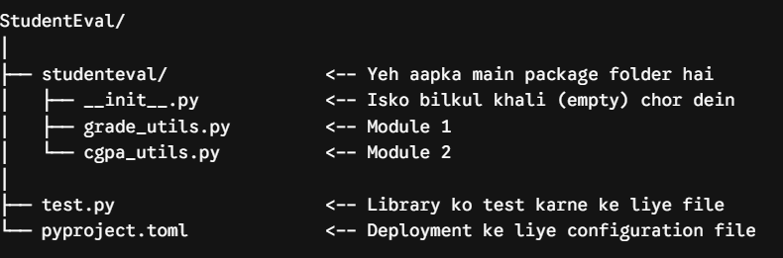

Project Title: GPA and Grade Calculator Python Library
1. Library Information
Library Name
GPA&GRADECalculator
Description
GPA&gradeCalculator is a Python utility library that helps students calculate grades, GPA, and CGPA quickly and accurately. The library converts marks or percentages into letter grades and grade points, and computes semester GPA as well as overall CGPA, making academic result calculation simple and reusable across projects.
2. Modules and Functions
Module 1: grade_utils
get_grade(marks)
Takes marks out of 100 and returns the corresponding letter grade (A, B, C, D, or F).
get_grade_point(marks)
Converts marks into a grade point on a 4.0 scale based on the institution's grading policy.
pass_fail(marks)
Checks the given marks against the passing threshold and returns whether the student has passed or failed.
Module 2: gpa_utils
calculate_gpa(grade_points, credit_hours)
Calculates the semester GPA from a list of grade points and their corresponding credit hours.
calculate_cgpa(semester_gpas, semester_credits)
Calculates the overall CGPA across multiple semesters using each semester's GPA and total credit hours.
percentage_to_gpa(percentage)
Converts a percentage score directly into an equivalent GPA value on a 4.0 scale.
4. Usage Demonstration
Example Program
from gpacalculator import get_grade
from gpacalculator import calculate_gpa
print(get_grade(85))
print(calculate_gpa([4.0, 3.7, 3.3], [3, 3, 3]))
Output
A
3.67
5. Conclusion
This project demonstrated the process of creating a Python library for GPA and grade calculation, organizing the code into modules, packaging the library, and publishing it on PyPI. The library can be installed using pip and reused in different Python projects. The project helped in understanding Python packaging, module creation, and library deployment, while also reinforcing the logic behind grade and GPA computation.

Screenshots: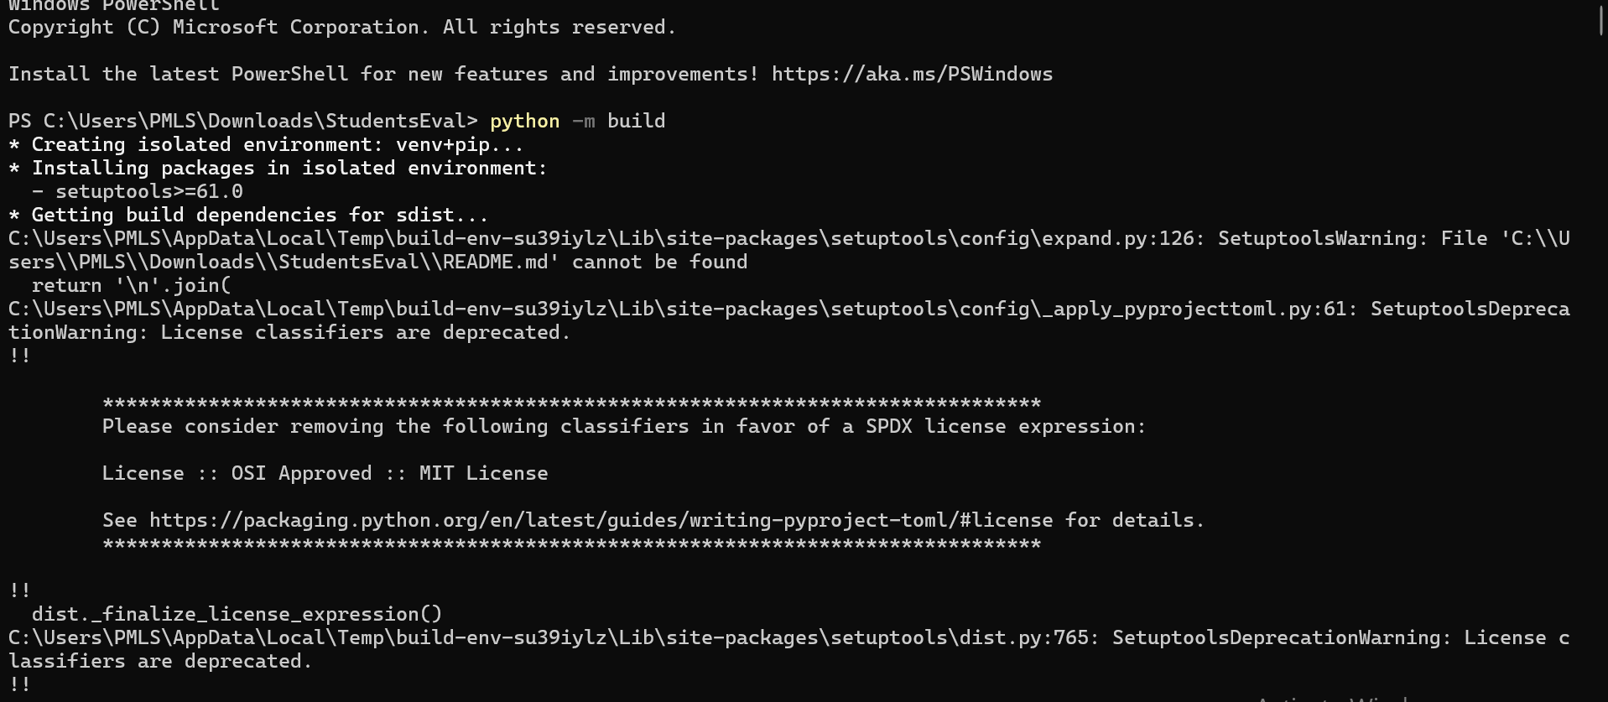
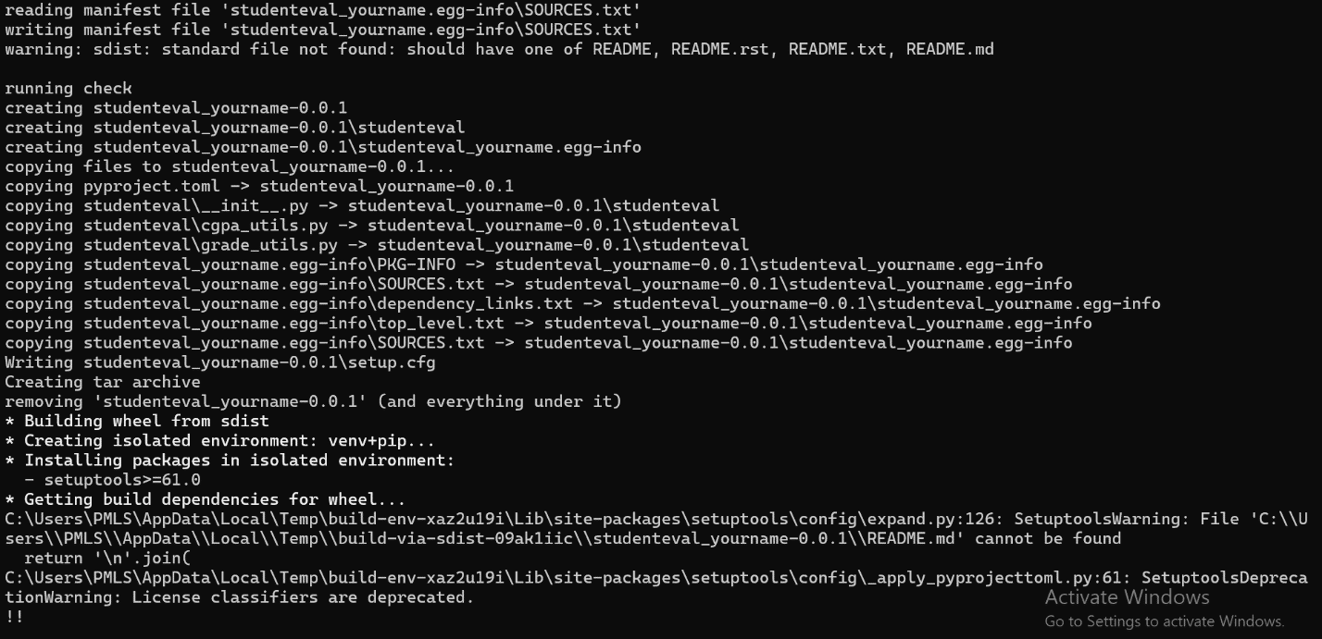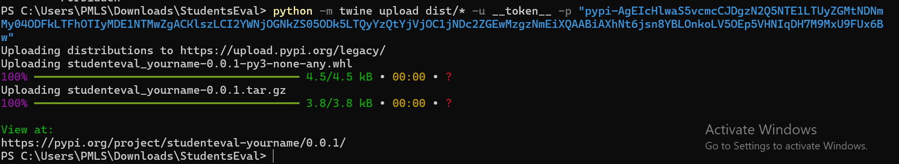

LINK: https://pypi.org/project/studenteval-yourname/0.0.1/

